Lab 14: Cross-site scripting - Reflected
Objective:
- This lab is dedicated to exploring Reflected Cross-Site Scripting (XSS) vulnerabilities, where malicious scripts are injected into a web application and reflected back to the user's browser. Participants will interact with a simulated web application that is vulnerable to reflected XSS attacks. The objective is to understand how to identify and exploit these vulnerabilities, as well as to learn effective mitigation techniques to protect web applications from such attacks.
In this lab, students need to:
- Answer the following questions:
  - What is Reflected Cross-Site Scripting (XSS), and how does it differ from other types of XSS attacks like Stored XSS and DOM-Based XSS?
  - Explain how Reflected XSS works, including how malicious scripts are injected and executed in the victim's browser, and discuss the typical attack vectors for this type of vulnerability.
- Perform challenge:
  - Reflected DOM XSS
- Explain and capture all steps (full windows screen capture).
Group Members:
- Phạm Hoàng Hải Nguyên (SE180511)
- Nguyễn Trúc Quỳnh (SE180280)
- Giã Thị Nhã Trân (SE180405)

Submit a report addressing all the questions mentioned above in either PDF or Markdown format. Additionally, include a video demonstrating the detailed process of your work to ensure the authenticity of your lab exercise.
The report file name must be Class_YourStudentID _YourName_Lab14

Reflected DOM XSS
This step shows the testing environment using Burp Suite Community Edition to capture and analyze HTTP traffic between the browser and the lab website.
The request and response panels display communication with the PortSwigger Web Security Academy lab server, confirming that the proxy interception is working.
On the right side, the vulnerable blog page for the Reflected DOM XSS lab is loaded, which will be used to test XSS payload injection through the search functionality.
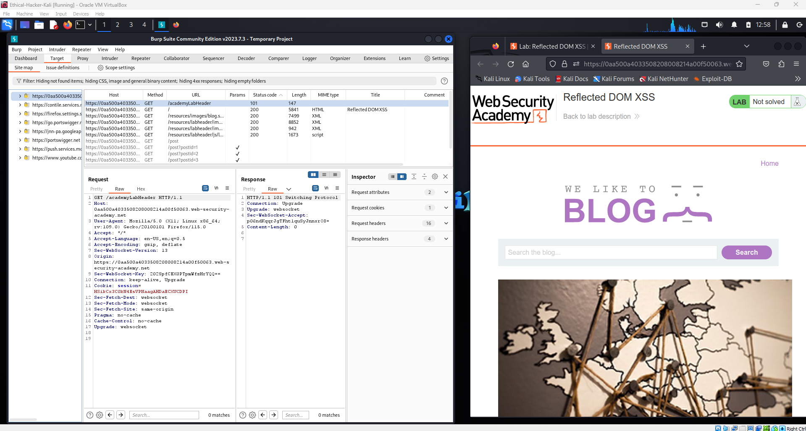

In this step, the tester enters the keyword “XSS” into the search bar on the vulnerable blog page from Web Security Academy.
The request generated by this search can be observed in Burp Suite Community Edition, allowing the tester to analyze how the input is processed by the application.
This helps identify whether the search parameter is reflected in the page and can potentially be exploited for a Reflected DOM XSS attack.
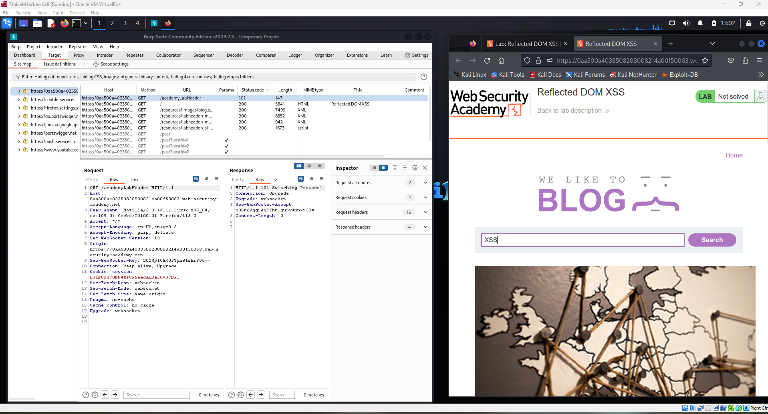

After submitting the search query “XSS”, the request /search-results?search=XSS is captured in Burp Suite Community Edition.
The response shows that the parameter searchTerm: "XSS" is returned in JSON, indicating that the user input is reflected by the application.
On the blog page from Web Security Academy, the message “0 search results for 'XSS'” confirms that the input is displayed on the page, suggesting a possible injection point for DOM XSS testing.
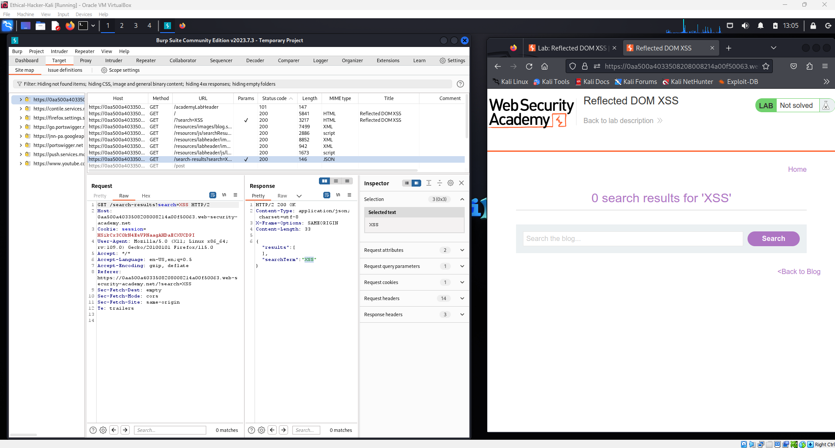

In this step, the tester inspects the JavaScript file /resources/js/searchResults.js captured in Burp Suite Community Edition.
The script processes the search query using window.location.search and dynamically inserts the result into the page DOM.
This behavior indicates a potential DOM-based XSS vulnerability because user input may be executed if it is not properly sanitized on the Web Security Academy blog page.
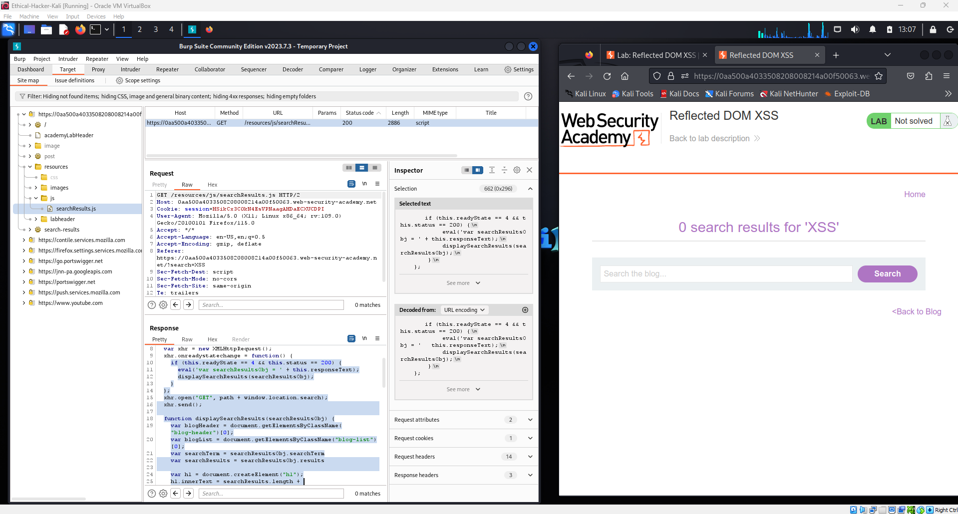

In this step, the tester reviews the lab instructions from Web Security Academy, which provide the payload used to exploit the Reflected DOM XSS vulnerability.
The instructions explain that the JSON response is processed using eval() and does not properly escape backslashes, allowing attackers to break the string and inject JavaScript code.
By entering the payload \"-alert(1)}//, the malicious script can execute in the victim’s browser, confirming the presence of the vulnerability.
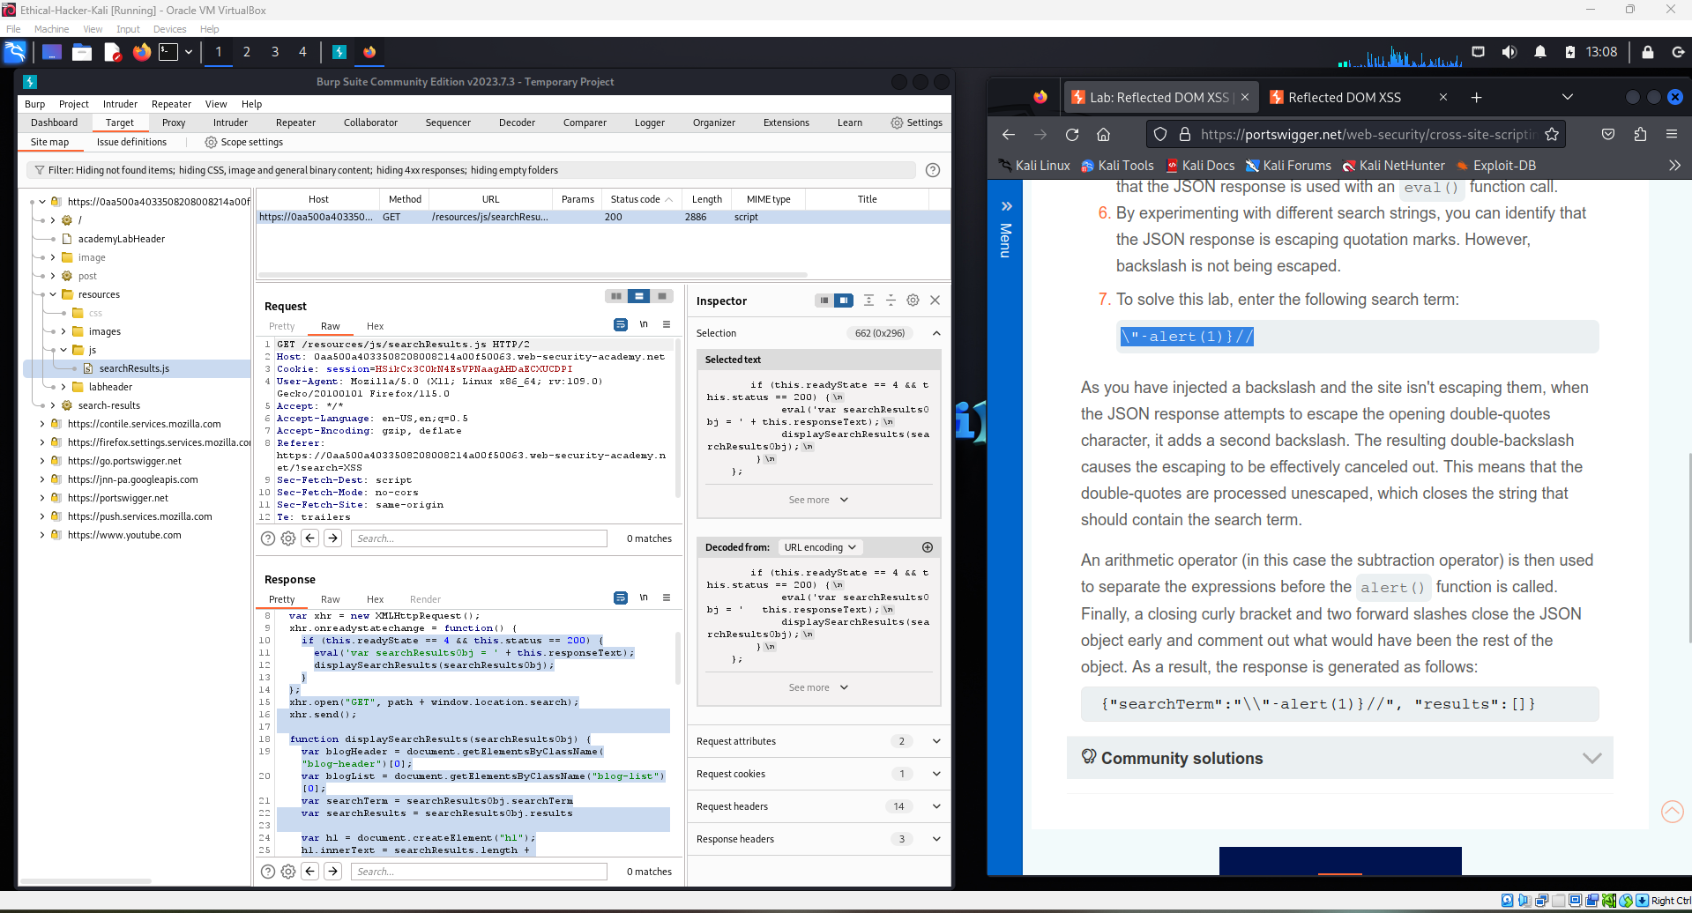

In this step, the tester enters the payload \"-alert(1)}// into the search field on the vulnerable blog page from Web Security Academy.
The malicious input attempts to break the JSON string and inject the JavaScript function alert(1) into the page.
If executed, this confirms that the application is vulnerable to Reflected DOM XSS due to improper input handling in the client-side script.
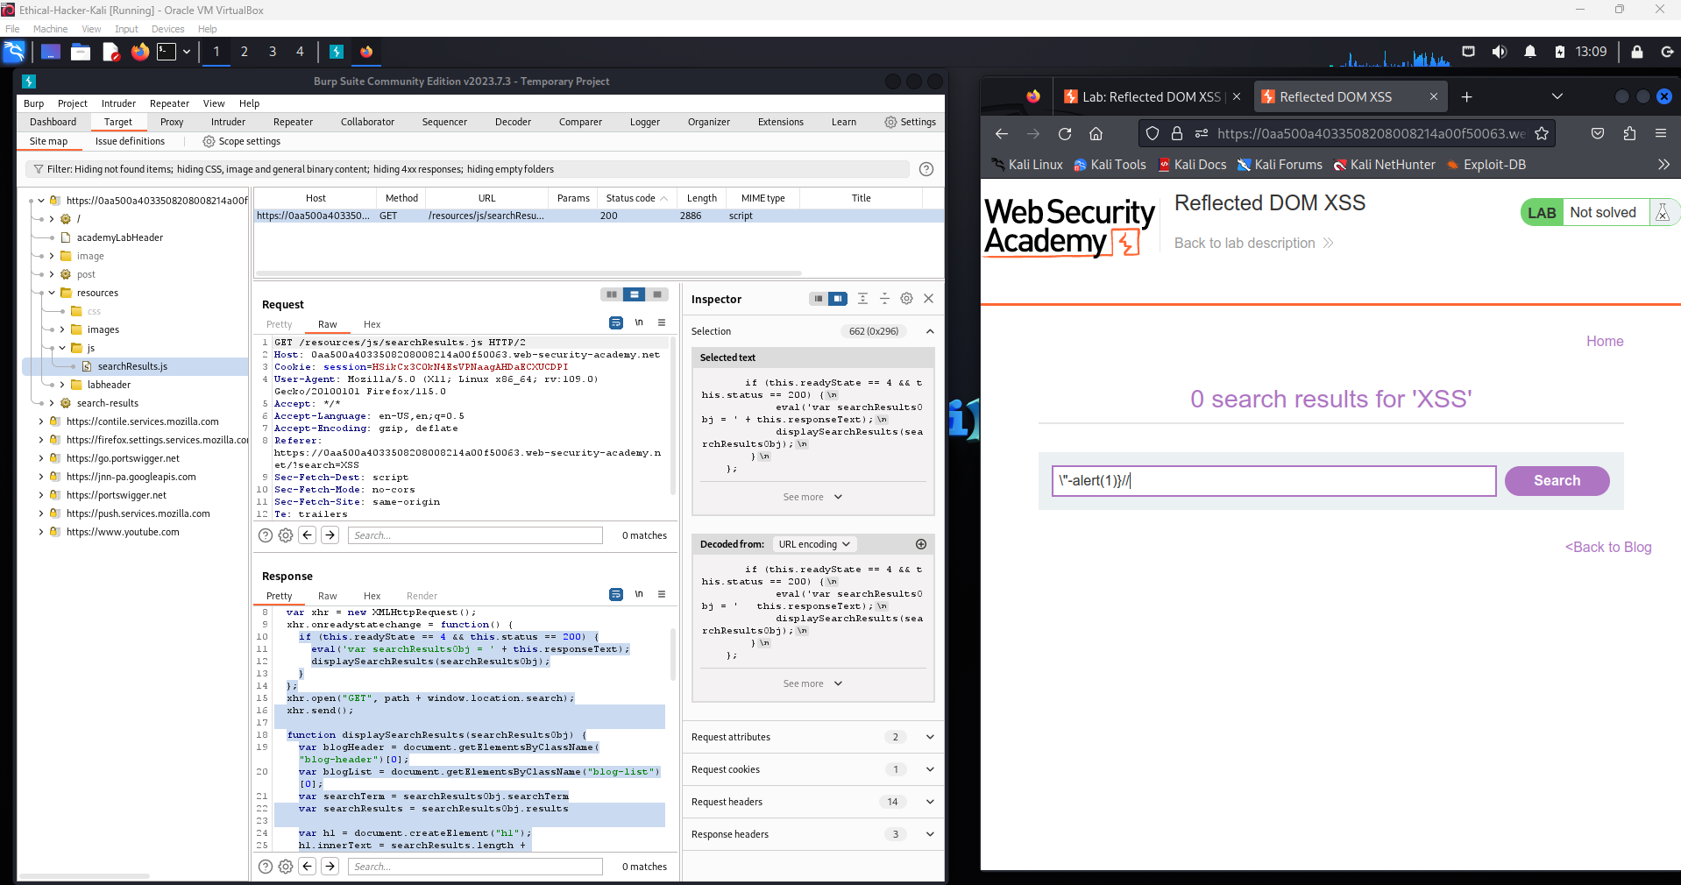

After submitting the malicious payload, a JavaScript alert box displaying “1” appears on the blog page from Web Security Academy.
This confirms that the injected script alert(1) has been executed successfully in the browser.
The result proves that the application is vulnerable to a Reflected DOM XSS attack.
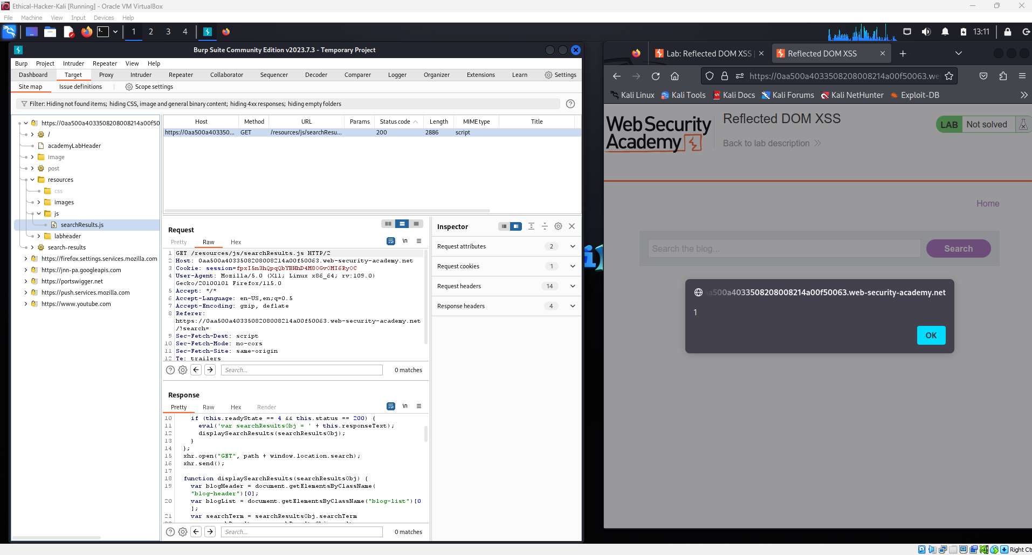

The malicious payload was injected into the search parameter and executed in the browser, demonstrating a Reflected DOM XSS vulnerability. The JavaScript payload (alert(1)) executed successfully, confirming that user input was improperly handled in the client-side script. The lab interface shows “Congratulations, you solved the lab!”, verifying the exploit was successful.
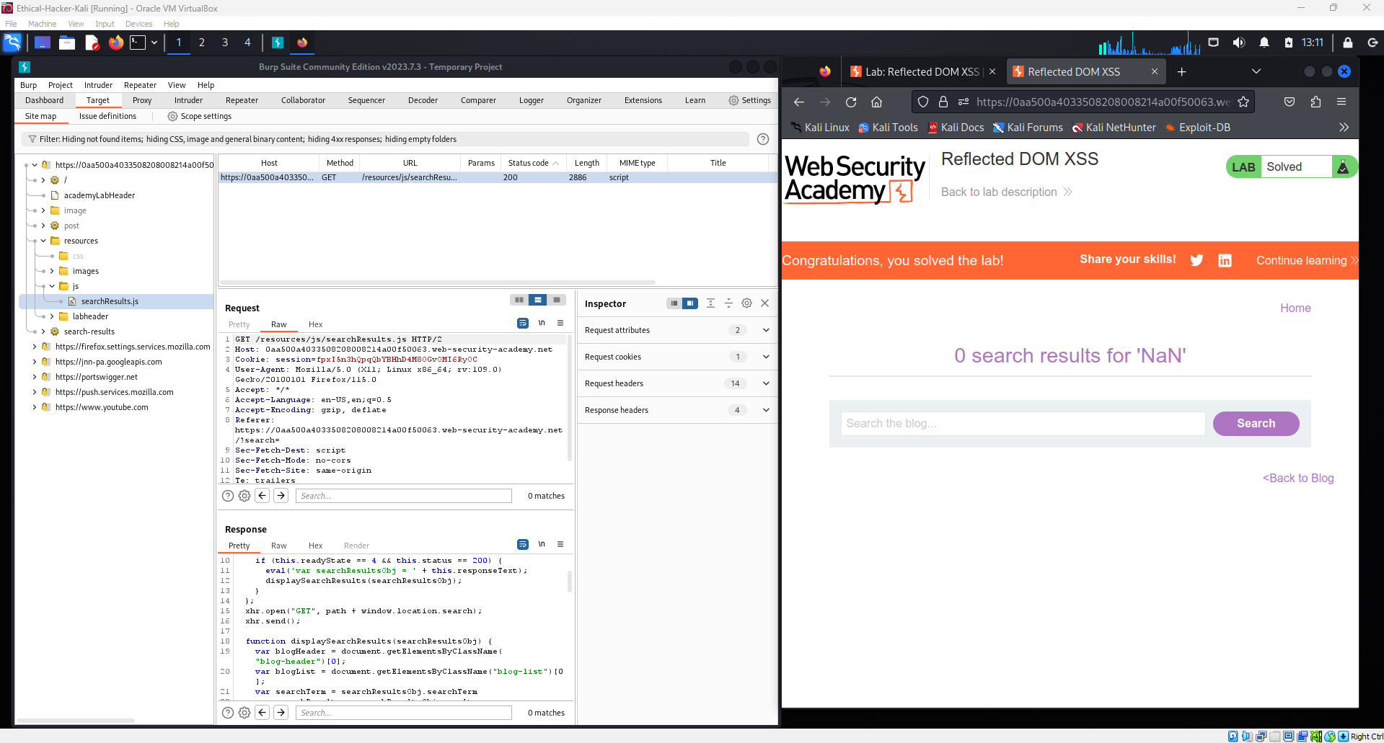

1. What is Reflected Cross-Site Scripting (XSS) and how is it different from other XSS types?
Reflected Cross-Site Scripting (Reflected XSS) is a type of web security vulnerability where malicious JavaScript code is injected into a web request and immediately reflected back in the web application's response. When the server includes this unvalidated input in the web page, the script is executed in the victim’s browser.
Reflected XSS is different from other types of XSS attacks:
Stored XSS (Persistent XSS)
In Stored XSS, the malicious script is permanently stored on the server, such as in a database, comment section, or user profile. When other users visit the affected page, the script automatically runs in their browsers. This type is considered more dangerous because it does not require the attacker to send a malicious link.
DOM-Based XSS
DOM-Based XSS occurs on the client side when JavaScript modifies the Document Object Model (DOM) using unsafe user input. In this case, the vulnerability exists in the browser’s script rather than the server response.
Reflected XSS
In Reflected XSS, the malicious script is not stored on the server. Instead, it is included in a request, such as a URL parameter, and reflected directly in the server response. The attack only works if the victim clicks or accesses the malicious link created by the attacker.

2. How Reflected XSS works and common attack vectors
Reflected XSS works by injecting malicious JavaScript code into a request that is sent to a vulnerable web application. If the application does not properly validate or sanitize the user input, the malicious script will be included in the web page and executed in the victim’s browser.
The attack process usually happens in the following steps:
Step 1 – Attacker creates a malicious payload
The attacker inserts JavaScript code into a URL or input field.
Example:
https://example.com/search?q=<script>alert('XSS')</script>
Step 2 – Attacker sends the malicious link to the victim
This link can be delivered through phishing emails, social media messages, or fake websites.
Step 3 – Victim clicks the link
When the victim opens the link, the request is sent to the vulnerable server.
Step 4 – Server reflects the input without filtering
The server includes the user input in the web page response without proper validation.
Step 5 – Script executes in the browser
The browser interprets the injected script and executes it, allowing the attacker to run malicious code.
Common attack vectors for Reflected XSS include:
- Search boxes
- URL parameters
- Login forms
- Contact forms
- Error messages
Through this vulnerability, attackers may steal session cookies, perform session hijacking, redirect users to malicious websites, or execute actions on behalf of the victim.
Tools such as Burp Suite and training platforms like Web Security Academy are often used to detect and practice exploiting these vulnerabilities.

Conclusion
Reflected XSS is a common web security vulnerability that occurs when a web application reflects user input in its response without proper validation or encoding. Attackers exploit this vulnerability by sending malicious links to victims, which execute harmful scripts in their browsers. Although Reflected XSS requires user interaction, it can still lead to serious security risks such as session hijacking, data theft, and phishing attacks.

Protection
To prevent Reflected XSS vulnerabilities, developers should implement several security measures:
1. Input Validation
Always validate and sanitize user input before processing it.
2. Output Encoding
Encode user input before displaying it on web pages to prevent browsers from interpreting it as executable code.
3. Use Content Security Policy (CSP)
Implement Content Security Policy to restrict the execution of unauthorized scripts.
4. Use Secure Frameworks
Modern frameworks such as React, Angular, and Vue.js automatically escape user input and reduce the risk of XSS vulnerabilities.
5. Regular Security Testing
Perform regular vulnerability testing using tools like Burp Suite to identify and fix potential issues early.

